

System level Integration of PSF

Information contained in this publication regarding device applications and the like is provided only for your convenience and can be superseded by updates. It is your responsibility to ensure that your application meets with your specifications. MICROCHIP MAKES NO REPRESENTATIONS OR WARRANTIES OF ANY KIND WHETHER EXPRESS OR IMPLIED, WRITTEN OR ORAL, STATUTORY OR OTHERWISE, RELATED TO THE INFORMATION, INCLUDING BUT NOT LIMITED TO ITS CONDITION, QUALITY, PERFORMANCE, MERCHANTABILITY OR FITNESS FOR PURPOSE**.**

Microchip disclaims all liability arising from this information and its use. Use of Microchip devices in life support and/or safety applications is entirely at the buyer’s risk, and the buyer agrees to defend, indemnify and hold harmless Microchip from any and all damages, claims, suits, or expenses resulting from such use. No licenses are conveyed, implicitly or otherwise, under any Microchip intellectual property rights.

|  |  |  |  |
| --- | --- | --- | --- |
| Microchip Technology, Inc. | | | Microchip Technology, Incorporated  2355 W. Chandler Boulevard  Chandler, Arizona 85224  480/792-7416 |
| REV | DATE | ORIGINATOR | DESCRIPTION OF CHANGE |
| 0.1 | 26-Aug-19 | Poornima R | Initial revision |
|  |  |  |  |
|  |  |  |  |
|  |  |  |  |

Table of Contents

1 Introduction 5

1.1 Terms and abbreviations 5

1.2 References 5

2 Software licence Agreement 5

3 Hardware Integration 5

3.1 UPD 350 5

3.1.1 Hardware Communication Interface 5

3.1.2 PIOs for UPD350 Alert 6

3.1.3 PIO for UPD350 Reset 6

3.2 Hardware Timer 6

3.3 DC-DC Buck boost controller 6

4 Software integration 7

4.1 Memory Requirement 7

4.1.1 32-bit MCU 7

4.1.2 16-bit MCU 7

4.1.3 8-bit MCU 8

4.2 Multi-Port Support Requirement 8

4.3 Endianness 8

4.4 API Implementation required for SW integration 8

4.4.1 Block Diagram – TBD 8

4.4.2 Data Types 8

4.4.3 APIs to be implemented by the user application 8

4.4.3.1 UPD350 Hardware Interface Configurations 8

4.4.3.2 PD Timer Configuration 8

4.4.3.3 UPD350 Alert Control 8

4.4.3.4 UPD350 Reset Control 8

4.4.3.5 SOC Interrupt Enable/Disable 8

4.4.3.6 Memory Compare and Copy 8

4.4.3.7 Structure Packing 8

4.4.3.8 Port Power Control 9

4.4.3.9 Boot time configuration 9

4.4.3.10 Hooks for Policy Manager 9

4.4.3.11 Debug Hooks 9

4.4.3.12 PD Firmware Upgrade 9

4.4.4 APIs to be called by the user application 9

4.4.5 Notification callback from PSF 9

# Introduction

## Terms and abbreviations

## References

# Software licence Agreement

# Hardware Integration

## UPD 350

UPD350 silicon is required for each port specifically. Zeus Stack supports UPD350 Rev A Silicon part with SPI Companion support i.e. UPD350/B, UPD350/D & UPD350/F parts of UPD350 Rev A.

### Hardware Communication Interface

**SPI Master:**

SPI master is required as Zeus stack interacts with UPD350 only through SPI interface. UPD350 SPI Slave supports maximum of 25MHz.

MCU SPI Master

CS 2

CS n

CS 1

SPI Bus

Port n UPD350

Port 2 UPD350

Port 1 UPD350

…..

*Note: ‘n’ denotes maximum number of ports.*

*cs denotes Chip select or slave select.*

2 Port Source and Sink solution is tested SPI Master with 8MHz.

### PIOs for UPD350 Alert

Alert line of each UPD350 must be mapped to individual GPIOs of MCU in the HW platform.

MCU GPIO Control

GPIO n

GPIO 2

GPIO 1

Port 1 UPD350 IRQ

Port n UPD350 IRQ

…..

Port 2 UPD350 IRQ

*Note: ‘n’ denotes maximum number of ports.*

### PIO for UPD350 Reset

## Hardware Timer

A Hardware timer with minimum resolution of 1ms is required for Zeus stack functionality.

The recommended resolution is 1ms.

## DC-DC Buck boost controller

UPD350 cannot drive higher PD voltages directly. A DC-DC converter is required to drive higher PD voltages.

For Source-only port, the setup would be as follows,

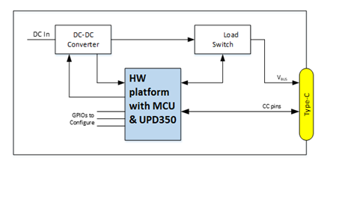

For Sink-Only port, the set up would be as follows,

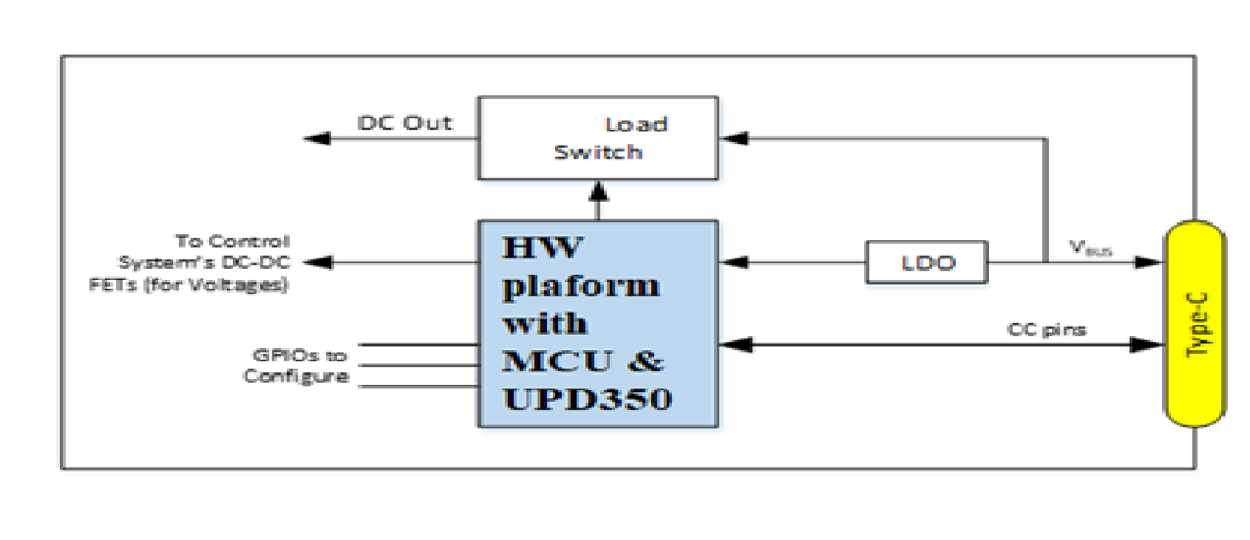

# Software integration

## Memory Requirement

### 32-bit MCU

* Estimated Code size of PSF Stack is 23KB for listed features in section Supported features.
* Estimated Data RAM size is 1KB (RAM for Stack operation) + 1KB per port.

*Note: Above mentioned memory estimate is only approximate.*

### 16-bit MCU

TBD

### 8-bit MCU

TBD

## Multi-Port Support Requirement

PSF supports maximum of 4 Port.

## Endianness

PSF stack supports only Little-Endian format.

## API Implementation required for SW integration

### Block Diagram – TBD

### Data Types

Explanation what is UINT8, UINT16,

### APIs to be implemented by the user application

List of APIs with Hyperlink in a table format

#### UPD350 Hardware Interface Configurations

Hooks required for SPI or I2C Initialization, Read and Write

#### PD Timer Configuration

Hooks and Macros required for HW Timer Initialization and Configuration

#### UPD350 Alert Control

Hooks to initialize the SOC PIOs used for UPD350 Alert control

#### UPD350 Reset Control

Hooks to Initialize the SOC PIO that Controls UPD350 Reset and to drive UPD350 Reset

#### SOC Interrupt Enable/Disable

Hooks to enable/Disable Global interrupts in SOC

#### Memory Compare and Copy

Hooks to copy and compare operations

#### Structure Packing

Macros for structure packing

#### Port Power Control

Hooks to overcome default GPIO Port power control (PortPower Init, VBUS Drive, VBUS Discharge, Sink Circuitry Control)

#### Boot time configuration

Hooks to modify configurable parameters at boot time

#### Hooks for Policy Manager

Hooks to run before and after Policy Manager Execution

#### Debug Hooks

Driver for printing debug messages

#### PD Firmware Upgrade

Hooks required for PDFU functionality

### APIs to be called by the user application

Hooks to be called by the SOC layer

* + MCHPPSF_Init()
  + MCHPPSF_Run()
  + MCHPPSF_UPDAlertHandler()
  + MCHPPSF_PDTimerHandler()

Note: The frequency at which the APIs to be called shall be captured

### Notification callback from PSF

Callback API that provide per port event like Detach, Attach, Powerfaults, UPD350Idle.